Professor Jonathan Gammell
Walter Light Hall, 609
613-533-6000 x78393
Queen's University, Kingston, Ontario
gammell@queensu.ca

Dear Dr. Jonathan Gammell,
Frozen Robotics Limited is pleased to present our proposal for our first-generation snow clearing robot proof of concept. This proposal aligns with all targets outlined in the MREN 403 2026-27 project definition you shared. Our product will help understand autonomous control of moving snow, cold and snowy weather operations, and navigation in environments changed by snow accumulation. These advances will help create more tools for our perspective customers to more easily, quickly, and regularly remove snow to reduce environmental hazards and improve grounds appearance.
Codenamed Frosty, our robot will be designed with a plow attachment, GNSS, LiDAR, and other sensors to follow a predefined path and understand it’s environment. Testing and development are planned to enhance the proof of concept with longer routes, enhance environmental understanding, and autonomous planning. The frosty robot will serve as a platform for continued development after our project is completed.
To ensure the platform is ready to go we have proposed below a system architecture to allow variety of testing possibilities to explore sensing in snow covered environments. We have also planned a system architecture that integrates a laptop or PC to ensure development and testing is not limited by compute resources.
We believe this will serve as the future of snow clearing and unlock great value for our customers.
Sincerely,
Lucas Balog | Julia Arturi | Quinton Rodgers | Skyler Zhou
 |  | 

Snow Clearing Robot Project Proposal
  - MREN 403 Group 9 2026-27
  - October 9th, 2026

Executive Summary
Project Frosty will create a proof-of-concept test system to clear snow with an autonomous four wheeled robot. The goal is to understand and create a platform that can navigate snow environment, push and move snow to create a clear path, and use appropriate safety restrictions limit dangerous interactions with humans. This system will allow for further work and development towards full autonomous clearing. Time permitting the team will create mapping and navigation systems to understand snow covered environments, generate snow clearing routes, and follow these routes while handling dynamic obstacles. Eventual our work will lead to a platform that will improve snow removal efforts by making operations more consistent to improve ground conditions and reduce liability risk for customers.

Purpose
Snow accumulation on pedestrian pathways presents an ongoing maintenance and accessibility challenge during Kingston winters. At Queen's University, the grounds team is responsible for clearing campus sidewalks and pathways, including City of Kingston sidewalks located within the university boundary. The project motivation is to investigate whether a portion of this repetitive snow-removal work can be automated, allowing maintenance personnel to focus their time and equipment on locations or conditions that require greater human attention.
The purpose of this project is to design and demonstrate an autonomous robotic system capable of repeatedly clearing snowfall from a known pedestrian pathway. The robot is intended to operate on a predefined route in a moderate-to-high traffic area of the Queen's University campus, where frequent clearing during a snowfall could help prevent accumulation while reducing the need for repeated manual shovelling.
This project aims to design and demonstrate an autonomous snow-clearing robot for predefined pedestrian pathways at Queen’s University. The prototype will integrate snow-clearing hardware, autonomous navigation, obstacle detection, and safety systems to demonstrate reliable operation with minimal human intervention.

Project Scope
The scope of this project is intentionally limited to the repeated autonomous clearing of shovel-able snowfall from a predefined pedestrian route on the Queen's University campus. The current project definition identifies a high-traffic campus walkway as the target environment, with the pathway between the ARC, JDUC, Mitchell Hall, and the Kinesiology building serving as the initial reference location.
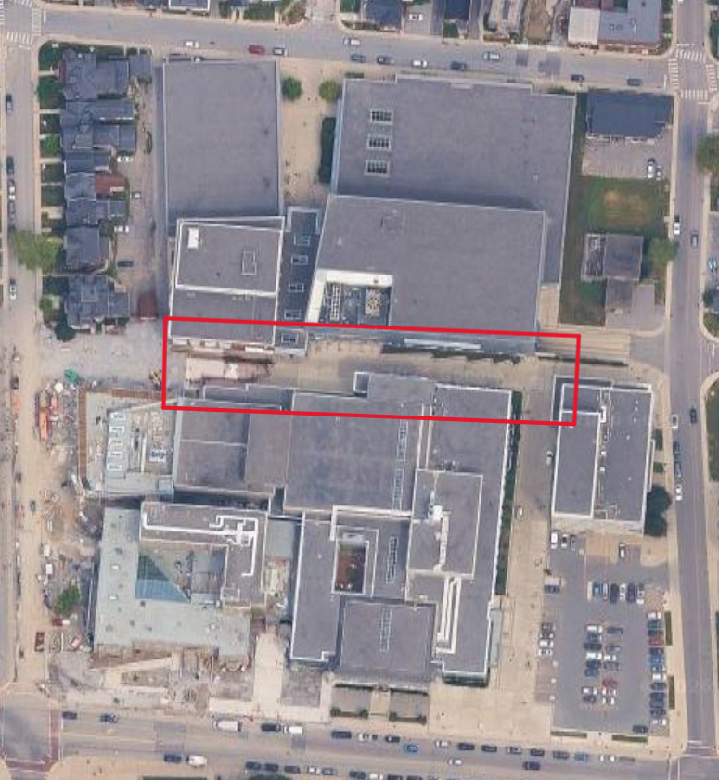
Figure 1: Identified pathway between the JDUC, Mitchell Hall the ARC, and the Kinesiology & Health Studies Building.
Operation would avoid the approximately ten-minute class crossover periods when pedestrian traffic is at its highest. A consultation with Queen's Physical Plant Services identified the east side of Botterell Hall as another possible test location, subject to approval.
The robot will be designed for fresh, light-to-moderate snow and slush that could be reasonably removed using a shovel or small plow. Deep packed snow, significant ice accumulation, and freezing rain are excluded from the intended operating conditions. The scope currently identifies a maximum snow depth of 5 cm, and an ambient temperature range of -15°C to 5°C.
Snow removal will be performed using a front plow, with a target clearing width of 75cm, approximately 10% wider than the robotic base.
The robot will autonomously follow a predefined route using a combination of teach-and-repeat and waypoint-based navigation, with path-planning methods used to modify the route when required. To support reliable navigation, the robot will combine GNSS, wheel encoder, and IMU measurements to estimate its position and motion. LiDAR and camera-based sensing will aide this localization by providing environmental awareness and enabling both static and dynamic detection of obstacles along the planned route. These sensing, localization, and navigation functions will be integrated within a ROS2-based architecture to allow the individual subsystems to operate as a coordinated autonomous system.
The robot must detect people and static obstacles in its path and respond by slowing or stopping and waiting until a path comes clear. The robot can be stopped using an on-board E-stop, remote stop, or upon the detection of any critical fault including communication failure. Manual control through a gamepad will be utilized for testing and system mobilization. A graphical user interface will provide basic operator information such as location, operating state, route progress, battery condition, and fault notifications.
Public road crossings will not be included, and the selected route will remain entirely within a pedestrian operating area. More advanced capabilities including automatic rerouting around unexpected obstacles, automated route creation, dynamic snow or ice detection, snow blowing, salt dispensing, and dynamic environmental perception will only be pursued if the primary functionality is completed successfully.

Review of State of the Art
Autonomous snow clearing robots are not a novel concept, however they recently have grown in popularity. Like many robotic innovations, initial research and development came in the form of a varsity competition. The Institution of Navigation’s (ION) annual Autonomous Snowplow Competition began in 2010, with the 3 competing teams meeting in Minnesota, USA. In 2026, the competition had 10 total teams, with teams from 5 different states, as well as Canada and Germany [1], showing that innovation is still occurring every year.
Outside of academia, snow clearing robots are becoming available at the consumer level. The first autonomous snow blower, the Yarbo, hit the market in 2022 [2]. The robot can operate at a minimum temperature of -25°C and handles packed and wet snow. Additionally, the Yarbo App allows for remote control, scheduling, and live robot state. Yarbo remains the most well-known solution for autonomous snow clearing but is far from becoming the new standard due to its very steep price point. The snow blower module costs $2200 USD alone, or $6199 USD with the actual robot [3], which is far more than the average homeowner would spend on a standard snow blower.

Technical Background of Product
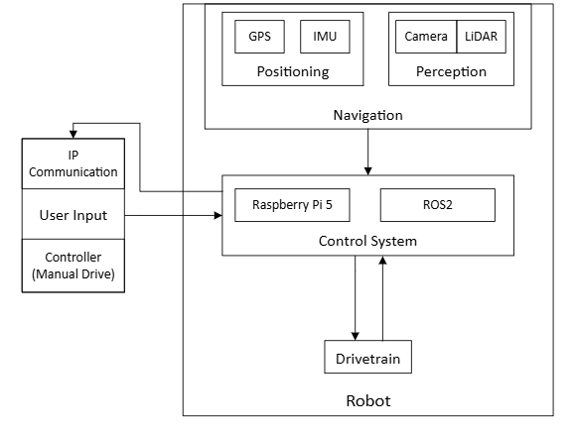
Figure 2: System architecture for snow clearing robot.
To achieve autonomy, the main technical problems to be solved are navigation and integration. For navigation, a variety of sensors will be used, including GNSS, IMU, LiDAR, and an RGB camera. The GNSS will be used for overall positioning in reference to a predefined map. The LiDAR will be used for object detection and localizing based on the external environment. This will include object/human detection for safety and additionally, allow for the potential of SLAM. A camera may also be used to assist in localization and can be used in tandem with the LiDAR to detect environmental change due to snow. The IMU and wheel encoders will provide accurate controller feedback. Additionally, the IMU can be used to detect if the robot is tipping.
For integration, ROS2 will be utilized as it allows for the different components and functions to be implemented modularly. RViz will be used to for simulation and to confirm functionality prior to physical integration. IP communication will be used to allow the user to control the robot and receive state-based notifications from the Raspberry Pi. A game controller will be used for manual driving during testing and movements.

Objectives
The robot’s primary objective will be to autonomously navigate a sidewalk or walking area to remove snow and create a safe working path. The project will help understand, the control methods of pushing snow as well as sensing and localisation complications in snow cover areas. The goal of our prototype will be to:
- Move and actuate in outdoor environments with 1cm to 5cm of snow at a temperature - range of -15°C to 5°C
- Keep at least 50% of the robot within a geofenced area
- Navigate a pre-defined path to clear snow 10m in length with one turn,
- Autonomously avoid static objects larger that 10x10x10cm
Secondary objectives if time allows in order of priority are:
- Observe environment to understand where snow remains and where plowing needs to be corrected
- Detection and problem solving for snow piles exceeding robot’s torque capabilities.
- Intuitive control environment for non-engineering professionals
- Run SLAM with Livox Lidar to understand environment and inform localisation for path following

Deliverables
Throughout the eight-month development period, the project will progress through a series of defined engineering milestones and supporting documents. These deliverables will document the lifecycle of the project from initial requirements and conceptual ideas through detailed design, implementation, testing, and final validation. Each milestone will provide an opportunity to assess the current state of the project, communicate key design decisions, and identify any changes required before progressing to the next stage. The table below outlines the major project deliverables and their targeted completion dates.
Table 1: Description of all seven deliverables and target date for submission
Deliverable | Description | Target Date
Project Proposal | Creates a definition for the project through the scope, purpose, objectives and current technology. | Fall Week 5 (October 9th, 2026)
Engineering Portfolio I | A snapshot of the state of the project. Includes design concepts, software, rationale for design choices. | Fall Week 9 (November 12th, 2026)
Joystick Control | The robotic base shall be controlled via an Xbox controller using differential drive control. | Fall Week 10 (November 20th, 2026)
Preliminary Design Review | A public presentation demonstrating the progress thus far. Focusing on current design and previous success/failures. | Fall Week 12 (December 4^{th,} 2026)
Engineering Portfolio II | A snapshot of the state of the project. Includes test plans, assemblies, integration steps and more. | Winter Week 4 (January 29th, 2027)
Robot Path Following | The robotic base shall autonomously follow a drawn GNSS path within the tolerance. | Winter Week 6 (February 12th, 2027)
Critical Design Review | A public presentation encompassing the final designs, expected risks, and validation plans. | Winter Week 8 (March 5th, 2027)
Prototype Demonstration & Technical Defense | A physical demonstration of the prototype removing material from a predefined path, with a posterboard showing an overview of the project term. | Winter Week 11 (March 25th, 2027)
Final Design Report | A summary report including the design calculations, test plans, software stack, and results. | Winter Week 12 (April 2nd, 2027)

Schedule
The project will span both the Fall and Winter semesters at Queen’s University [4], with final system validation and project completion targeted for the period immediately before the Winter semester exam period. The development schedule is structured around a series of major engineering milestones and supporting documentation, as outlined in Table 1. These milestones are intended to provide defined points for evaluating project progress, reviewing design decisions, and confirming readiness to proceed to subsequent stages of development.
An important constraint on the project schedule is the availability of adequate environmental conditions for testing. As the system is designed for autonomous snow clearing, meaningful validation requires representative snow conditions that cannot be controlled by the project team. Historical climate data for Kingston indicates an average of approximately 83 days per year with at least 1 cm of snowfall, with the majority occurring during January and February [5]. Accordingly, full-system testing will be prioritized during this period to maximize the opportunity for realistic evaluation of the snow-clearing system. Initial subsystem and functional testing will be conducted independently of snowfall where possible to ensure that the system is prepared for environmental testing when suitable conditions occur.
The schedule also accounts for periods when project activity may be reduced, including the Fall and Winter reading weeks and the Christmas break. These periods have been incorporated into the project timeline to provide realistic expectations for team availability and to reduce dependencies on work that requires the full team to be present.
Development of the mechanical, electrical, and software subsystems will occur concurrently throughout the project. While major milestones establish the overall progression of the project, subsystem development will remain iterative, allowing designs to be tested, evaluated, and refined as the system develops. Internal targets will therefore be used to monitor progress between formal milestones and ensure that the project remains on schedule. The Gantt chart below provides an overview of the planned development timeline, including major engineering activities, project milestones, and documentation requirements.
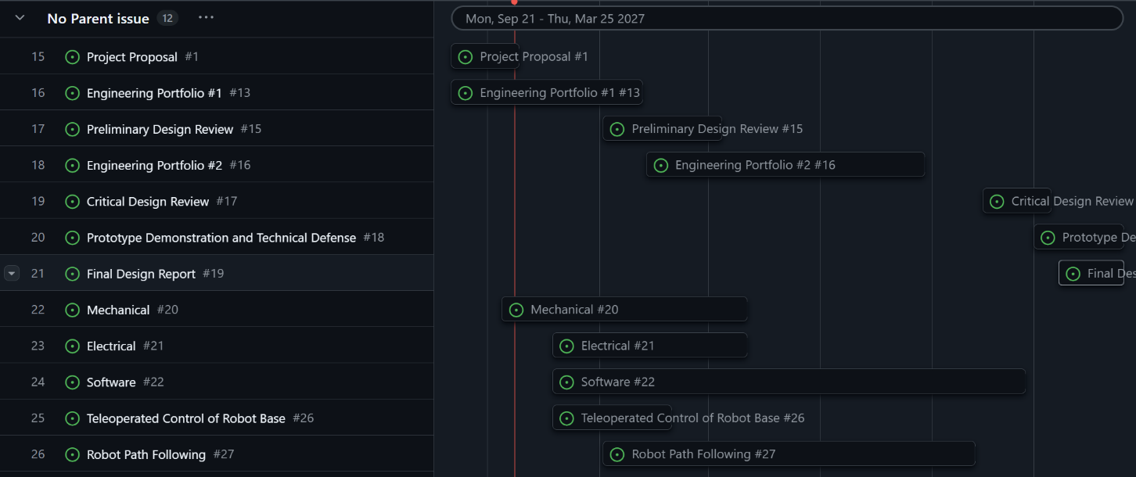
Figure 3: Gannt chart displaying project schedule from Sept. 2026 through Apr. 2027. This chart includes the 7 primary deliverables and 3 major project components

Budget and Resources
A project budget of $500 has been allocated to support the procurement of components and materials required for the development and testing of the autonomous snow-clearing robot. The anticipated purchases are summarized below, along with equipment and components provided by the project team or available through project resources.
Table 2: Team budget and allocated materials from Smith Engineering
Purchased | Estimated Cost | Quantity | Supplier
Snow Shovel | 100$ | 2 | Canadian Tire
Camera | 200$ | 1 | TBD
Battery + Management System | 200$ | 1 | TBD
Total | 500$
Provided | Quantity | Source
Robotics Chassis | 1 | TBD
GNSS | 1 | Prof. Gammell
Vicon LiDAR | 1 | Prof. Gammell
Raspberry Pi 5 | 1 | Prof. Gammell
Linear Actuator | 2 | Offroad Robotics

Team Qualifications
The team consists of four final-year Mechatronics and Robotics Engineering students at Queen’s University. The members and their roles are as follows:
Skyler Zhou is the ROS lead. They have gained experience in ROS2 and SLAM through a previous academic project in which a mobile robot was programmed. Involvement in the AutoDrive design team further deepened their understanding of SLAM as they assisted in detection fusion. Skyler has also just returned from a 16-month internship at Kruger Pro. Their time within a manufacturing facility greatly enhanced their mechanical aptitude and understanding of system integration. It also showed them the importance of defining a proper scope and understanding the stakeholders.
Lucas Balog is leading the networking, remote communication, and system integration. He previously completed a 12 month internship as a Mechatronics Designer with ATS automation, Life Sciences Innovation division. There he developed the next generation of Symphoni synchronous assembly technology and SuperTrak linear movement technology. He led the retrofit of a test system for new generation automation control working with and interpreting feedback from Mechanical, Electrical, Control, and Business stakeholders.
Quinton will lead the structural design of the robot; through his QUIP experience at Bruce Power he was provided with practical project management skills, such as guiding complex troubleshooting plans involving multiple stakeholders along with mechanical design of prototypes of new products. Furthermore, his involvement with FIRST Robotics as a technical volunteer and mentor has provided the necessary skills to work on electrical and control systems along with complex troubleshooting in a quickly evolving environment. Finally, his experience on the AutoDrive design team introduced designing and building a sensor suite to competition specifications. The combination of experiences along with the desire to learn will contribute to the development, integration and testing of the autonomous snow-clearing system.
Julia possesses a core focus in Electric Machines, Power Electronics, Mobile Robotics and Machine Vision and Learning. She has 16-months of industry experience working in Process Controls for the development of Nylon 6-6 at INVISTA in Kingston, Ontario. Here she focused primarily on DCS programming, working in Function Block Diagrams, Structured Text, and Sequential Function Charts. Her primary work surrounds answering the question of — how can we automate everyday processes to get somewhere more stable and reliable?

References

[1] | Institution of Navigation, "Autonomous Snowplow Competition," [Online]. Available: https://mail.autosnowplow.com/welcome.html. [Accessed 5 October 2026].
[2] | Yarbo Inc., "About Us," [Online]. Available: https://www.yarbo.com/pages/about-us?p=b. [Accessed 5 October 2026].
[3] | Yarbo Inc, "Yarbo Snow Blower," [Online]. Available: https://www.yarbo.com/products/yarbo-snow-blower. [Accessed 5 October 2026].
[4] | Office of the University Registrar, "Key Dates," Queen's University, [Online]. Available: https://www.queensu.ca/registrar/key-dates. [Accessed 30 September 2026].
[5] | Environment and Climate Change Canada, "Canadian Climate Normals," Environment and Climate Change Canada, 2020. [Online]. Available: https://climate.weather.gc.ca/climate_normals/index_e.html. [Accessed 30 September 2026].

